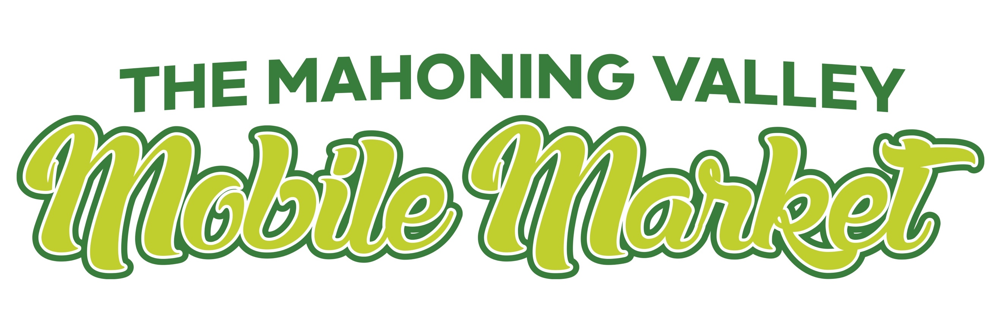

**Nov 2022**

**Nov 16 - Wednesday**

ESA Park Apartments 10-12

110 Kendis Cr, Youngstown

Grovewood Manor 12:30-2:30

3531 Hillman, Youngstown

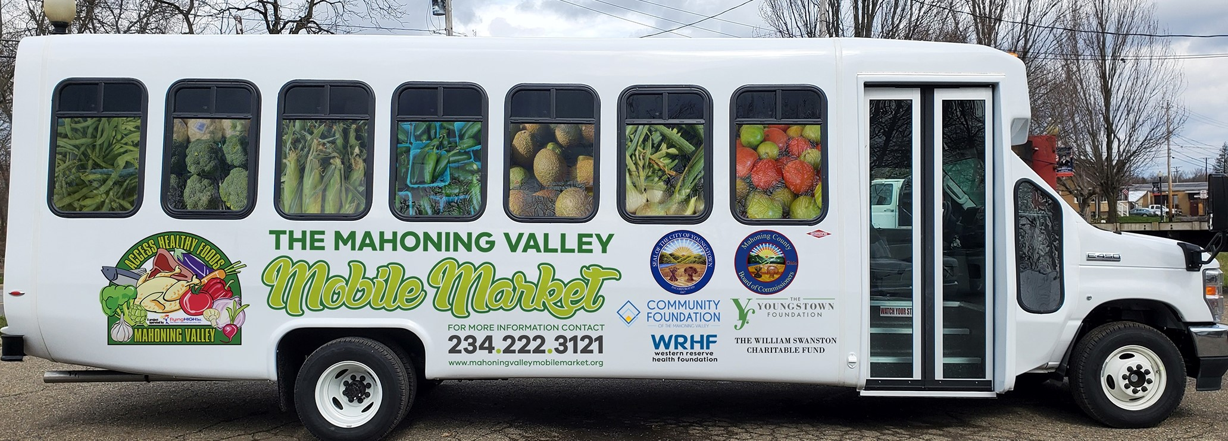

**Oct 18 - Friday**

Carter House 10-12:00

26 Willis, Youngstown

Villages at Arlington 12:30-2:30

516 Griffith St, Youngstown

**Nov 17 - Thursday**

Gutknech Towers 11-2

110 E. Wood St, Youngstown

**Nov 22 - day**

Sebring Library! 11-2

195 W. Ohio Ave, Sebring OH

**Nov 21 - Monday**

Calvary Towers 10-12:00

1840 Market St, Youngstown

Newport Library 12:30-2:30

3730 Market, Youngstown

**Nov 9 - Wednesday**

Levy Gardens 10:00-11:30

584 Granada, Youngstown

Amedia Plaza 11:45-1:00

131 W. Boardman St, Youngstown

Arlington Gardens I 1:15-2:30

767 Park Ave, Youngstown

**Nov 11 - Friday**

International Towers 10-12:00

25 Market St, Youngstown

Main Library 12:30-2:30

305 Wick Ave, Youngstown

**Nov 10 - Thursday**

Norton Manor 9:45 - 11:00

1400 Springdale, Youngstown

East Library 11:15-12:45

430 Early Rd, Youngstown

Plaza View 1-2:30

1446 McGuffey Rd, Youngstown

**Nov 5 – Saturday**

Love Thy Curves Dress Fest 11-2

6900 Market St, Youngstown

**Nov 2 - Wednesday**

Lowellville Park Apts 10-11:45

810 W. Wood St, Lowellville

Vasu 12:15-2:30

137 Roosevelt, Campbell

**Nov 3 - Thursday**

Struthers Manor 10-1

585 Poland Ave, Struthers

Kirwan Homes 1:30-2:30

101 Jackson St, Campbell

**Nov 4 - Friday**

Freedom Village 10-11

1356 N. Osborn, Youngstown

Austintown Senior Center 11:15-12:45

112 Westchester Dr., Austintown

Broadway Park 1:15-2:30

353 Broadway, Youngstown